# Houdini Tips

### Houdini Env

https://www.toadstorm.com/blog/?p=722

### Houdini Python

Read point attribute and write xml file

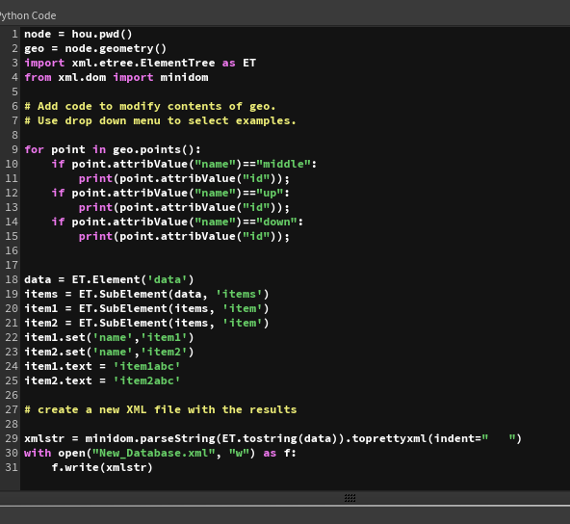

Houdini python $HIP location

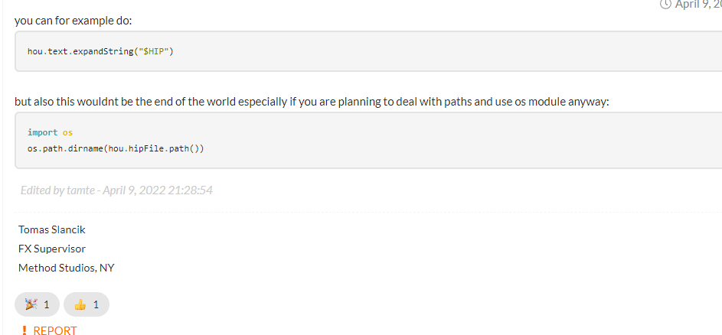

Get Houdini node parameter value

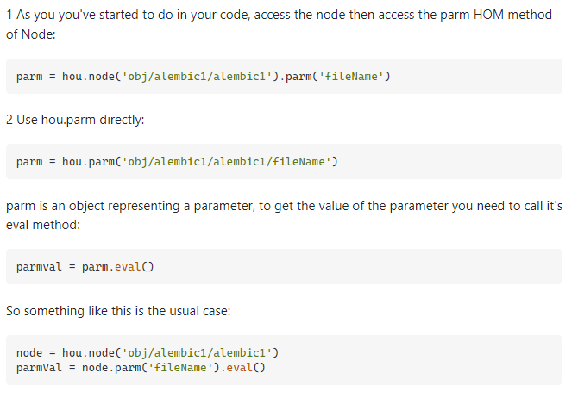

Os.path.mkdir(“path”)

### Button

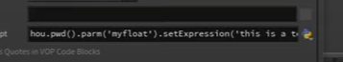

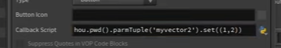

Environment variable

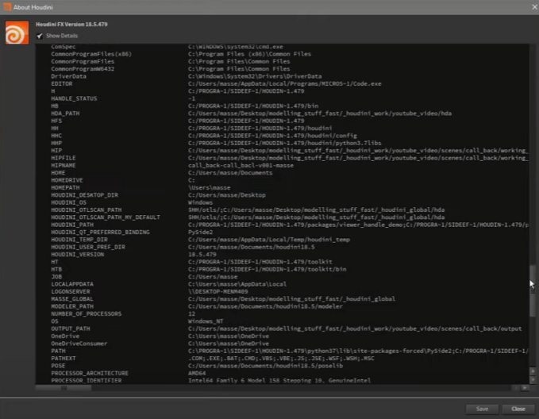

Syspath

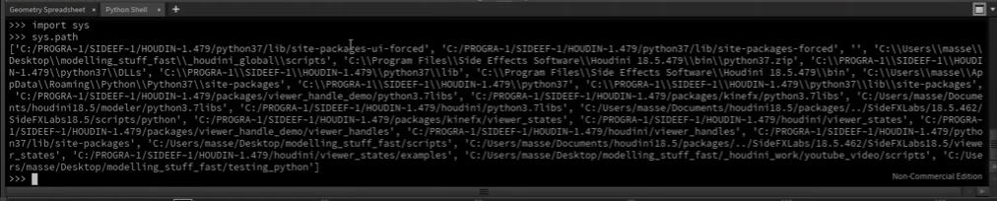

Type property is global, parameter is local in node